**CMPS 350 Project Phase 2 – Report**

**Education Platform**

**(10% of the course grade)**

**The report must be submitted in Word format only**

|  |  |
| --- | --- |
| **Group Members** | Faisal Elbadri (202107288)  Mohammed Elanjjar (202205158)  Abdulla Jamali (202104080)  **Emails:** [fm2107288@qu.edu.qa](mailto:fm2107288@qu.edu.qa); [me2205158@qu.edu.qa](mailto:me2205158@qu.edu.qa); [aj2104080@qu.edu.qa](mailto:aj2104080@qu.edu.qa); |
| **GitHub link** | Give a public link to you code (It is not acceptable to send codes by email) |

**Grades :**

**The student fills only the “Implementation Percentage”: Please specify either: *Working (completed x%)*, *Not Working (completed x%)* or *Not done*.**

|  |  |  |  |  |
| --- | --- | --- | --- | --- |
| **Criteria** | **%** | **Functionality**\* | **Quality of the implementation** | **Grade** |
| Design and implement the Data Model. | 10 |  |  |  |
| Init DB: populate the database with the data from the json files in seed.js | 5 |  |  |  |
| Server actions, APIs and Repository Implementation to read/write data from the database | 25 |  |  |  |
| Statistics use-case with NextJS | 40 |  |  |  |
| **Documentation**  - Data Model diagram.  - UI Design with screenshots and description.  - Database queries.  - Conducted tests and evidence.  - **Contribution** of each team member [-10pts if not done] | 20 |  |  |  |
| **Total** | 100 |  |  |  |
| Copying and/or plagiarism or not being able to explain or answer questions about the implementation. | -100 |  |  |  |

**Important remark: In case of copying and/or plagiarism or not being able to explain or answer questions about the implementation, you lose the whole grade.**

**\* Criteria for grading the functionality:**

- The functionality is working: you get 70% of the assigned grade.

- The functionality is not working: you lose 40% of assigned grade.

- The functionality is not implemented: you get 0.

- The remaining grade in all cases from above **is assigned to the quality of the implementation**,

- The grades are distributed on the various use cases, when the design/implementation is partial, you get only the grades of designed/implemented use cases.

Code quality criteria, include:

- Use of meaningful identifiers for variables and functions (e.g. using JavaScript naming conventions)

- Pages are responsive

- Clean code: simple and concise code, no redundancy

- Clean implementation without unnecessary files/code

- Use of comments where necessary

- Proper code formatting and indentation.

**You lose marks** for code duplication, poor/inefficient coding practices, poor naming of identifiers, unclean/untidy submission, and unnecessary complex/poor user interface design.

**Important Remark**:

**[Grades: 100-85]:** Will be given only to **fully functional application** with **all the quality criteria cited above met** and the project has excellent **design for the various functionalities**. **The report is professional**.

**[Grades: 85-80]:** Will be given only **to functional application** **with most of all the quality criteria cited above met** and the project has good design for the various functionalities. **The report is professional**.

**[Grades: 80-75]:** 80% of the application functionalities are functional. The project respects partially the quality criteria. **The report is professional** but misses some information.

The grades are not negotiable. We expect that only a small portion (around 15%) of the class will be able to meet the criteria for the grades **[100-85]. You should work hard to and demonstrate the merits of your application to earn those grades.+**

# Description of your proposed platform

Give an overview of how your application works

# Data Model

Give entity diagram, Prisma schema,

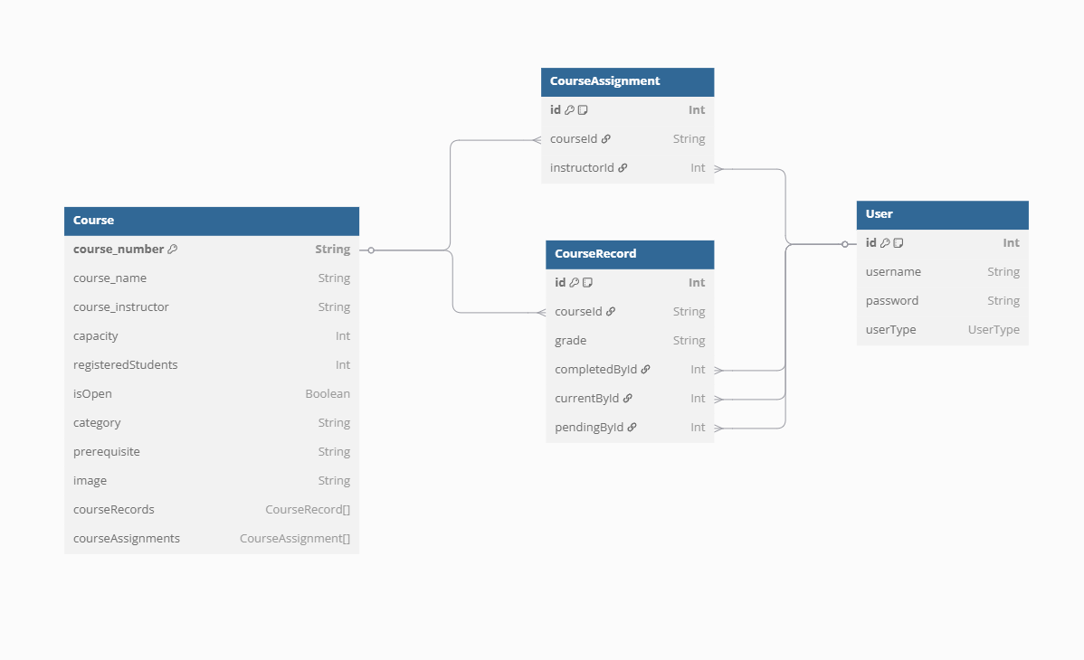

# Web API, Server Actions and repository

List all your implemented methods (functions) to query your data,

Show how you organized them in WebAPI and Server actions

# Implemented statistics use case

# User Interface

# Implemented queries

# Data used in the statics

# Conducted tests

# Implemented queries

# Discussion of the project contribution of each team member

|  |  |
| --- | --- |
| **Student name** | **Student contributions** |
| Faisal Elbadri |  |
| Mohammed Elanjjar |  |
| Abdulla Jamali |  |
|  |  |
|  |  |